**Name:** Nnadiekwe David Chiderah

Monitoring and Reporting using Cloudwatch

Create an Amazon CloudWatch alarm to monitor your estimated charges in your AWS account as follows:

Setup a threshold of $15.

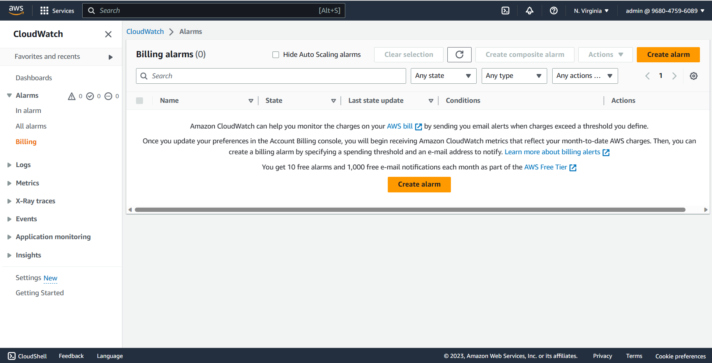

Setup a notification alert to your email when the threshold is breached.

Confirmation for subscription to topic



